**CLM CPQ Integration**

Functional Capabilities of CLM

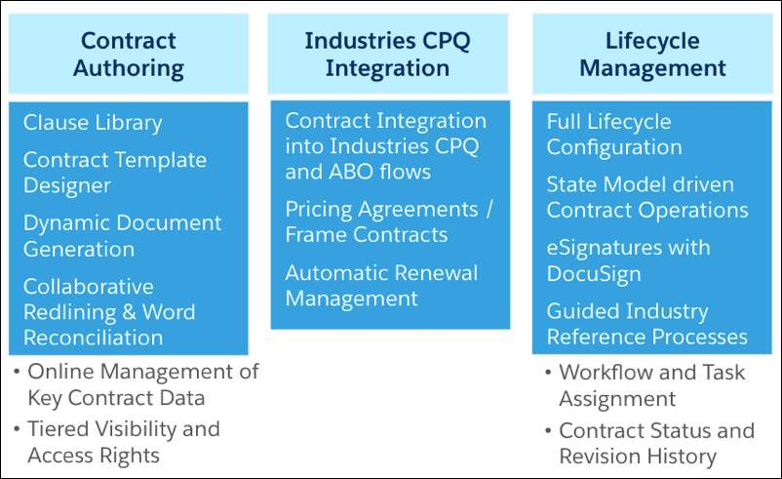

One of the functional capabilities of CLM is integration with Industries CPQ (Configure Price Quote) which gives it more of a CME flavor.

* **Contract Integration into Industries CPQ:** Contracts are integrated within the CMT sales process. You can create a contract from an opportunity, quote, or order, and it flows to the next stage of the sales process. You can send the contract for internal approvals before you send it to the customer during the negotiation stage.
* **Frame Agreement Components:** We can also drive the pricing of quotes or orders based on pre-negotiated frame contracts.
* **Automatic Renewal Management:** Send renewal notifications for expiring contracts to ensure revenue opportunities are not missed. Create renewal opportunities and assign them to the right salesperson. You can search for contracts, view contract reports, view and audit trail of actions performed on contracts.

# Contract to Contract Relationships

CLM support three types of Contract to Contract relationships. Customers can use these appropriately to organize contracts that are related to each other.

Relationship Types

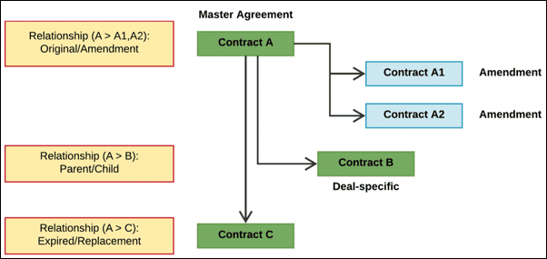

There are 3 types of contract to contract relationships.

* Original/Amendment: one master contract (A) with new contracts (A1 and A2) created for amendments.
* Parent/Child: a deal-specific contract B is created under the master agreement Contract A.
* Expired/Replacement: Contract C replaces the expired Contract A.

**Frame Agreements**

A frame agreement is a pricing-based agreement that you negotiate with a customer for a list of products and services over a given period of time. This type of contract drives the pricing of related quotes/orders based on the agreement line item prices.

**Contract General Terms**

For sales contracts or frame agreements, contract administrators can define General Terms.

* General Terms are non-pricing terms, such as payment period, termination notice period, warranty duration, and so on.
* General Terms are set up with attributes containing picklists.
* Users, such as salespeople, can set values for attributes in the General Terms inherited by its Contract Type. For example, if the General Term “Payment Terms” has an attribute called “Payment Period,” users can select the picklist value of 45 days for that specific contract or frame agreement.
* Contracts inherit contract terms on creation